EXECUTIVE SUMMARY  ADVANTAGE VALLEY REGION  HOUSING NEEDS ASSESSMENT  This update evaluates housing needs across the 10-county region and compares current market conditions with the January 2024 assessment to identify changes, constraints and development opportunities.  PRIMARY STUDY AREA: Boone, Cabell, Clay, Jackson, Kanawha, Lincoln, Mason, Putnam, Roane and Wayne counties. |  |  |  |  |  | 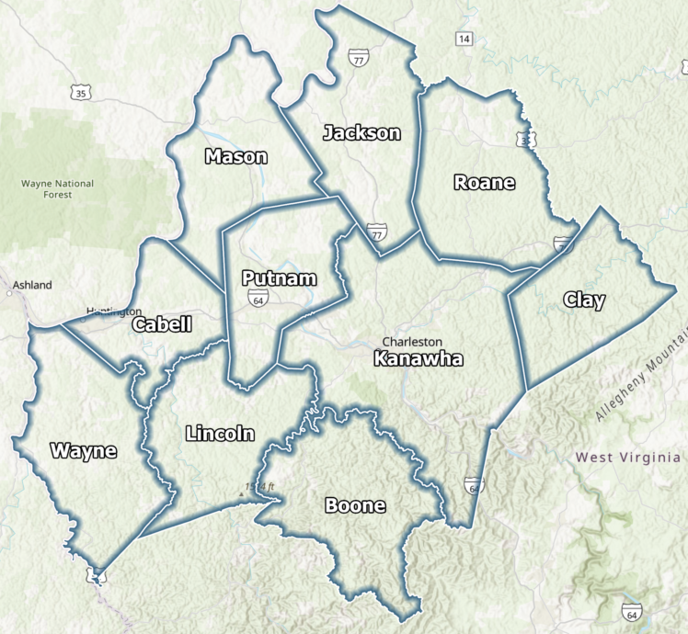
28,976  TOTAL FIVE-YEAR HOUSING GAP |  |  | 10,604  RENTAL UNITS NEEDED |  | 18,372  FOR-SALE UNITS NEEDED |  |  | 17,268  PROJECTED DIRECT & INDIRECT JOBS
1 | KEY TAKEAWAYS | THE MARKET AT A GLANCE
   | CHANGING DEMOGRAPHIC TRENDS  The baseline five-year household decline slowed from 1.5% (2023-2028) to 1.0% (2026-2031). A job-influenced projection indicates a net gain of 9,764 households.
   | RENTAL AVAILABILITY IS CRITICALLY TIGHT  The 161 multifamily projects surveyed are 98.4% occupied, which is a high rate. More than 1,300 households remain on affordable-rental wait lists.
   | GROWING SENIOR INFLUENCE  Households age 75+ are projected to grow 15.0% by 2031, while continued losses among households under the age of 35 could limit long-term growth.
   | FOR-SALE INVENTORY REMAINS LIMITED  Only 621 homes were available, representing an extremely low 0.4% availability rate. The median sales price increased $62,875, or 44.2%, from 2020 to 2025.
   | HOUSEHOLD INCOME GROWTH  Growth among renters earning $50,000+ and owners earning $100,000+ will increase demand for moderate- and higher-end housing.
   | HOUSING GAPS CREATE OPPORTUNITY  The rental need spans various income levels, while 62.5% of the for-sale gap is for homes affordable to households earning $100,000+. As such, development opportunities exist.
   | ECONOMIC INVESTMENT IMPACT  Planned investment is expected to add 3,808 direct and 13,460 indirect or ancillary jobs, increasing housing demand.
  AFFORDABILITY AFFECTS THE WORKFORCE
  More than 20,000 households are severely cost burdened. Most leading occupations cannot afford the typical home on one wage.
GROWTH READINESS  Housing production must keep pace with job creation so employers can attract workers and commuters can become residents. |  |  |  | PRODUCT DIVERSITY  The region needs senior-friendly options, attainable workforce rentals, and a broader range of ownership choices. |  |  | MULTIPLE SOLUTIONS  New construction, adaptive reuse, rehabilitation, and financial assistance are all needed to close the housing gap.
THE REGIONAL  HOUSING IMPERATIVE |  | Housing supply must expand at multiple price points so the region can capture planned job growth, serve aging households, retain younger adults and reduce housing cost burdens.  SENIOR-READY • WORKFORCE RENTAL • OWNERSHIP CHOICE • PRESERVATION

2 | MARKET SNAPSHOT & HOUSING NEED | DEMOGRAPHICS, ECONOMY, SUPPLY AND IMPLEMENTATION
The region combines strong job-driven potential with severe supply constraints and persistent affordability pressure.
DEMOGRAPHICS  72.7%  OWNER HOUSEHOLDS  • Households declined 12,416 (-5.7%) from 2010 to 2026; 79.3% of the loss occurred before 2020.  • Projected 2026-2031 region change: -2,116 households (-1.0%); Jackson and Putnam counties are projected to grow.  • Household growth (2026-2031) for age 35-44: +1.6%; age 75+: +15.0%.  • 45.1% of renters are projected to earn below $35,000 in 2031.  • 2,307 units are overcrowded; 2,034 lack complete kitchen or plumbing facilities. |  |  |  |  | ECONOMY & AFFORDABILITY  17,268  PROJECTED DIRECT & INDIRECT JOBS  • 53.7% of leading occupations cannot afford typical rent; 80.3% cannot afford the typical home on one wage.  • Unemployment improved from 6.0% in 2016 to 4.6% through April 2026.  • Jobs located in the region increased by 1,620 (+0.8%) since 2023.  • Nonresident commuters represent 48.2% to 67.6% of individual county workforces.  • 42,930 households pay more than 30% of income for housing; 20,172 are severely burdened, paying over 50% toward housing. |  | HOUSING SUPPLY  98.4%  MULTIFAMILY OCCUPANCY  • 161 projects and nearly 11,400 multifamily units were surveyed.  • Only 184 non-conventional rentals (e.g., houses, duplexes, etc.) were available - a 0.5% vacancy rate. Rents range from $850 for a one-bedroom unit to $1,800 for a four-bedroom unit.  • Only 621 homes were listed for sale - a 0.4% availability rate, which is very low.  • 2025 median sales price: $205,000; April 2026 median list price: $179,900.
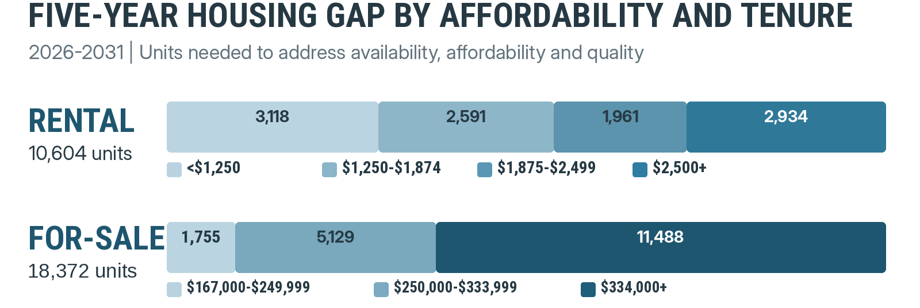
28,976  TOTAL UNITS NEEDED |  |  | WHAT THE GAP MEANS  The estimate addresses availability, affordability and housing quality through a combination of new construction, rehabilitation and financial assistance. |  |  |  |  |  | 62.5%  OF FOR-SALE GAP IS FOR HOUSING PRICED AT $334K+
3 | PRIORITIES FOR IMPLEMENTATION | A COORDINATED REGIONAL RESPONSE
01  EXPAND ATTAINABLE RENTALS  Increase workforce, affordable and senior rental options to relieve wait lists and near-full occupancy. |  |  |  | 02  ADD HOMEOWNERSHIP CHOICES  Support entry-level, move-up and higher-end product so job growth can translate into household growth. |  | 03  PRESERVE EXISTING HOUSING  Rehabilitate aging or substandard units and pair repairs with affordability and ownership assistance. |  | 04  COORDINATE GROWTH TOOLS  Align infrastructure, land use, incentives and public-private partnerships around priority development sites.
ABOUT THE  ESTIMATES |  | Estimates reflect current policies, incentives, demographic and economic trends, and available or planned units. Actual project support will vary by design, pricing, target market, quality and location; demand could exceed these estimates if policies or incentives encourage additional household and housing growth.
Source: Bowen National Research, Advantage Valley Region Housing Needs Assessment, 2026 Update.

